**Water Footprinting Model Testing**

21 August 2013

**Overview**

**Model Download**

The model can be accessed through Github (<http://github.com/>). An account with Github is necessary to access the model. To access the model it is necessary to create a local repository on your computer. The program for accessing Github on your computer using windows or Mac can be found here: <http://windows.github.com/> or <http://mac.github.com/>.

Directions for the use of the Github programs should be included with installation. However, the general goal is to clone and then sync the shared repository that contains the water footprinting model so you can access it from your local Github repository. The default location for that repository is under “My Documents”

Please note that as a model tester you cannot ruin our water fooprinting model by make changes and accidently committing those changes to Github. The permanent version of the model is hosted separately on an internal NREL system. The Github version of the model only represents the semi-public representation. Therefore, let us know if you need help reversing changes to the model committed to Github

Please let NREL know if we need to fix a problem with model so those changes can be ported to the internal version of the model.

**Documentation of Model Testing**

Feedback from the tester can primarily be recorded in this document through responses to questions included below on page 6.

If the model tester feels that it is necessary, please return a more lengthy attachment with full comments on the model, schedule a meeting with the BioLUC team, or tag model issues on the Github website (<https://github.com/NREL/waterfootprint/issues>). Issues with the model that are tagged on the Github and the development team will be automatically notified.

**Timeline**

Begin Testing – September 7th

End Testing – September 21st

Meeting to Discuss Model Testing (if needed) – September 22nd – 25th

**Estimated Usage of the Model Tester’s time**

* Variable, depending on the interests of the tester.
* Minimum: 4-8 hours in order to download the model and evaluate the basic plausibility of the Water Footprinting model.
* Maximum: 2-3 days if all aspects of the model are explored in depth.

**Overview of the Water Footprinting Modeling System and Data**

We developed a water footprinting model that contains a system dynamics (SD) component and a soil and climate database framework. The system dynamics component was created using the STELLA Version 9.1.4 software package (ISEE Systems, Lebanon, New Hampshire) using a stock-and-flow structure. The water footprinting model currently uses Cligen(1) for climatic conditions and STATSGO(2) for soil conditions.

Figure 1 illustrates the water footprinting model’s macro data process. The water footprinting model consists of four main components including the database framework for managing data, the Stella model, a Visual Basic for Applications automation script, and visualization of results. The database structure provides a storage and query environment for processing raw data, generating model inputs and storing outputs for visualization of results.

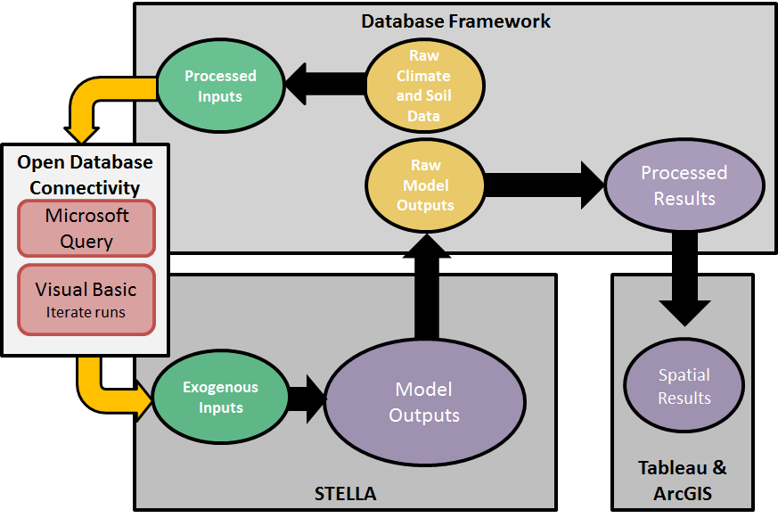

**Figure 1.** Water footprinting model, data processing and management diagram.

A process of runs was developed in Visual Basic for Applications (VBA) to loop through each cligen spatial location, import its associated soil and climate exogenous inputs into the model, run the model and generate output. Within Microsoft Excel, VBA automates the model runs using Microsoft Query Language and Object Database Connectivity (ODBC), and the VBA code integrates the Stella command line to iterate through the runs.

Outputs from the system dynamic model runs of for each spatial location station are processed in the database framework for upload connectivity to into Tableau and ArcGIS for data visualization. Outputs include blue and green water for each crop class in the model including perennial forage, annual forage, corn, feed crop, fiber crop, grain, oil crop, sugar crop, winter grains and soybeans.

Equations in the Stella model are based on FAO’s Penman-Monteith method.(3) which are based on a modification to the Penman-Monteith method.(3) The Penman–Monteith method estimates evapotranspiration as the product of a reference crop evapotranspiration (ETo) and a crop coefficient (Kc), as shown in the equation below.

$${ET}_{C}=K_{C}*{ET}_{O}$$

ETc is total evapotranspiration (mm day−1) from a crop “c”. Kc accounts for plant characteristics such as albedo and crop height that distinguish a crop from the reference surface. Kc represents a crop based constant that varies from 0 to 1. ETo represents the reference crop evapotranspiration (mm day−1). The ETo characterizes climate effects and is based on a calculation using temperature, solar radiation, wind speed, and relative humidity as shown in the equation below.

$${ET}_{O}=\frac{0.408Δ\left(R_{n}-G\right)+γ(\frac{900}{T+273})u_{2}(e_{s}-e_{a})}{Δ+γ(1+0.34u_{2})}$$

* Δ = slope of the vapor pressure curve (kPa per ◦C)
* T = average air temperature (◦C)
* γ = psychrometric constant (kPa per ◦C)
* es = saturation vapor pressure (kPa)
* ea = actual vapor pressure (kPa)
* Rn = net radiation at the crop surface (MJ per m2 day)
* G = soil heat flux (MJ per m2 day)
* u2 = wind speed at 2 m (m per s).

We are using endogenous calculations for most of the parameters in the Penman-Monteith question. For example, crop coefficient curve can be calculated for each station from exogenous Cligen data instead of just using a standardized crop coefficient curves. By bringing the Penman-Monteith method into a system dynamics framework we are calculating the water footprint for each DT and integrating over the model run.

Figure 2 illustrates the generalized influence diagram of the system dynamics model for calculating green and blue water consumption.

* Orange oval boxes represent inputs from the processed Cligen and STATSGO data in the database
* Diamond boxes representing controls or switches in the Stella model. Controls are sometimes determined by users in the system dynamics model, but can also be determined endogenously based on soil and climate data or other user decisions.
* White oval boxes represent important endogenously calculated variables.
* Rectangular boxes and arrow represent the stock and flow of green and blue water resources (as indicated by the colors used).

Blue water consumption per Mg of agricultural feedstock is estimated using yields and crop evapotranspiration rates. Green water is determined by the available soil water and crop evapotranspiration rates. Available soil water is constrained as determined by average precipitation and soil texture. Crop evapotranspiration is calculated based on an evapotranspiration reference surface and an endogenous or exogenous crop coefficient that depends on user choice. Behind the crop coefficient curve and reference surface calculations is climate and soil input data and other user determined assumptions.

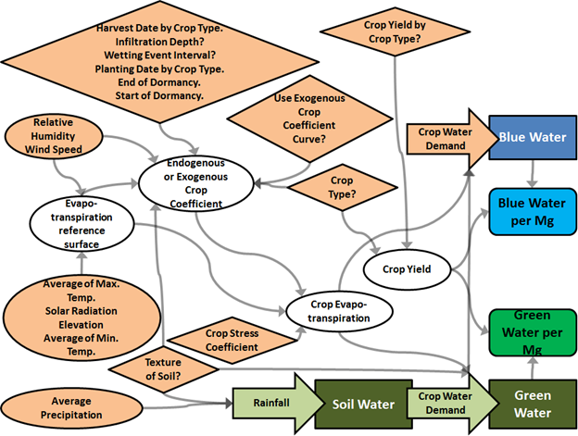

**Figure 2.** System dynamics model overview influence diagram.

**Running the Model**

1. Open the water footprinting model in your version of Stella 10.0.3. Conversion is fine. The model should still function.
2. Select the crop type to be evaluates, annual or perennial.
3. Review tables for crop yields, planting dates for annuals, harvest dates for annuals, and dormancy rates for perennials. Make changes if these values seem incorrect. You can scroll through each table through the drop down menu.
4. What is the soil texture of the site under evaluation? Heavy = clay, medium = loamy, light = sandy.
5. Choose an initial soil moisture level. See the "read me" documentation for soil moisture levels and textures located with files associated with the water footprinting model.
6. Define the initial wetting conditions for the region under evaluation. For most scenarios, 10 mm infiltration depth is appropriate. The days between events is the number of days per month divided by the ratio of the mean rain event and the mean monthly precipitation.
7. Select the height of the crop during the middle of the growing season and at the end of the growing season.
8. If the crop is drought tolerant, use the Ks slider to adjust the degree of tolerance, otherwise leave at 1.
9. To run the model, press the green “run” button.

**Water Footprinting Model Testing**

*Of the testing sections below we are primarily interested in testing and verification related to “Validity of Methods” and “Running the Model”. Tackling other issues is important, but do not need to be addressed if the tester does not have the time.*

|  |  |  |
| --- | --- | --- |
| **Questions** | **Yes** | **No** |
| ***Running the Model*** |  |  |
| Were there any issues opening up the model? |  |  |
| Were instructions enough to run basic water footprinting scenarios? |  |  |
| Are results plausible? Please examine multiple conditions. |  |  |
| ***Validity of Methods (based on the description included above on the model and data)*** |  |  |
| Do the water footprinting modeling methods seem valid? |  |  |
| Is the Cligen dataset an acceptable data source for the water footprinting methods used? |  |  |
| Is the STATSGO dataset an acceptable data source for the water footprinting methods used? |  |  |
| Is the model’s regional planting and/or harvest assumptions reasonable? |  |  |
| Do you have any critiques about the above datasets we are using? |  |  |
| ***Usability of the User Interface*** |  |  |
| Are labels clear and accurate? |  |  |
| Are the graphs and tables clear? |  |  |
| Does the user interface reasonably provide the ability to run and interpret water footprinting scenario? |  |  |
| ***Vetting of Model Structure*** |  |  |
| Are the equations in the model accurate? |  |  |
| Are data processing steps valid? |  |  |
| Are variable names clear and appropriate? |  |  |
| Is the internal system behavior reasonable as inputs are altered? |  |  |

*Please elaborate on your answers to these questions or address other issues you think are important in the section below.*

**Additional Comments:**

**References:**

1. United States Department of Agriculture (USDA). *Cligen*. In: (USDA) USDoA, editor. (2013).

2. United States Department of Agriculture (USDA). *STATSGO2*. In: (USDA) USDoA, editor. (2013).

3. Allen RG, Pereira LS, Raes D, Smith M. *FAO Irrigation and Drainage Paper*. Rome, Italy: FAO; (1998). 333 p.